Olusegun Afolabi
EECE 412
Professor Wenjie
2/26/2025

Lab 5
Introduction
This project involves implementing a digital logic operation unit using VHDL (VHSIC Hardware Description Language) on the Basys 3 FPGA board. The objective is to create a logical operation unit that uses conditional signal assignment statements to perform various logical operations, such as XOR, AND, OR, and NOT, based on a 4-bit control signal. The implementation involves writing VHDL code, simulating the design, and testing it on the FPGA board to verify the correct operation of the designed circuit.
Concept
The logical operation unit uses a 4-bit control signal (ctrl[3:0]) to determine which logical operation to perform on two 1-bit input signals (a and b). Depending on the binary value of the control signal, the unit will execute one of the following operations:
- ctrl = 1--- → XOR operation (a xor b)
- ctrl = 01-- → AND operation (a and b)
- ctrl = 001- → OR operation (a or b)
- ctrl = 0001 → NOT operation (not b)
- ctrl = 0000 → NOT operation (not a) The design employs a priority encoding structure, where the highest priority bit in ctrl dictates the selected operation, ensuring only one logical operation is executed at any given time.
Procedure
- Created a new project in Vivado, ensuring that VHDL was selected and the Basys 3 board was chosen.
- Using the base VHDL code provided, wrote the code to implement the schematic of the design unit provided.
- Added the design file to the project and included the Basys 3 Constraint file.
- Edited the Basys 3 Constraint file to include 4 switches representing ctrl[3:0], two switches representing a and b one-bit input signals, and one LED light representing output x.
- Clicked Run Linter, then clicked Open Elaborated Design.
- Opened the schematic and identified the components of the schematic and how they relate to the code.
- Compared the schematic to my manual diagram based on the code written.
- Synthesized & Implemented the design on Vivado.
- Generated Bitstream and programmed the FPGA board.
- Captured snapshots of test inputs and outputs.

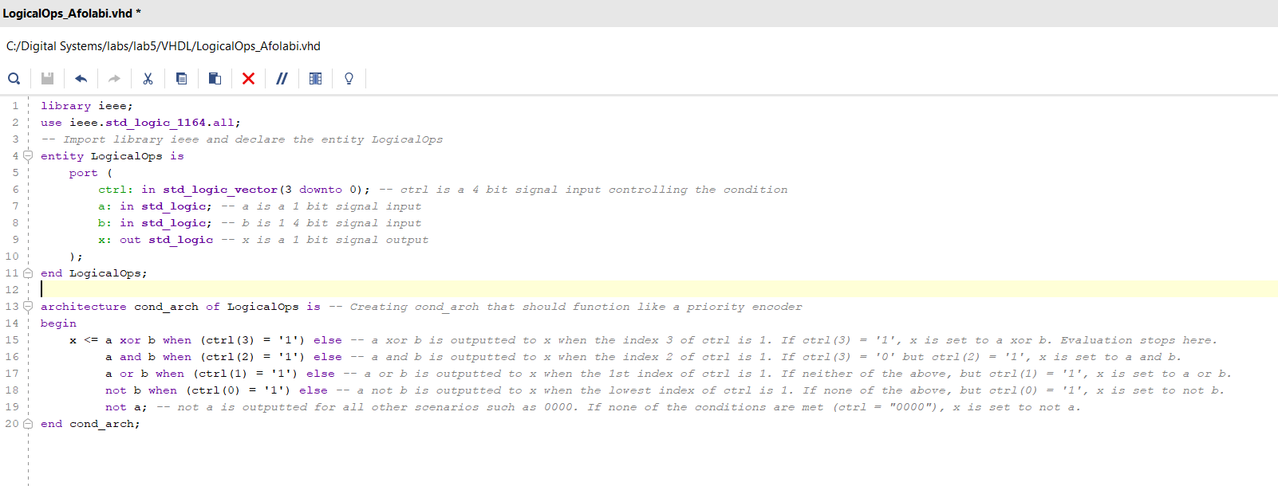

Comparison Between Manually Drawn Diagram & Vivado Schematic
The manually drawn diagram and the Vivado-generated schematic both represent the logical operation unit described by the VHDL code. The primary difference lies in how the priority encoding is represented. The manual diagram uses a simplified approach, showing the priority encoder as a single block with prioritized control signals directly managing the output selection. It captures the essential logic operations (XOR, AND, OR, NOT) and their connections to the priority encoder, which determines the final output based on the "ctrl" vector.
In contrast, the Vivado schematic expands this priority encoding into a more detailed and explicit hardware implementation. Instead of a singular priority encoder block, Vivado uses multiple multiplexers (RTL_MUX) connected in series. These multiplexers evaluate the priority of control signals in a cascading manner, effectively achieving the same priority logic but through a more granular hardware representation. Each multiplexer handles a specific conditional scenario, aligning with the "when-else" priority structure of the VHDL code.
The key takeaway is that while the manually drawn diagram offers a high-level and conceptual view of the priority encoder, the Vivado schematic breaks this down into a lower-level hardware realization using individual multiplexers to maintain the conditional priority in the design. Both approaches are correct, with Vivado providing a more hardware-centric, detailed representation.
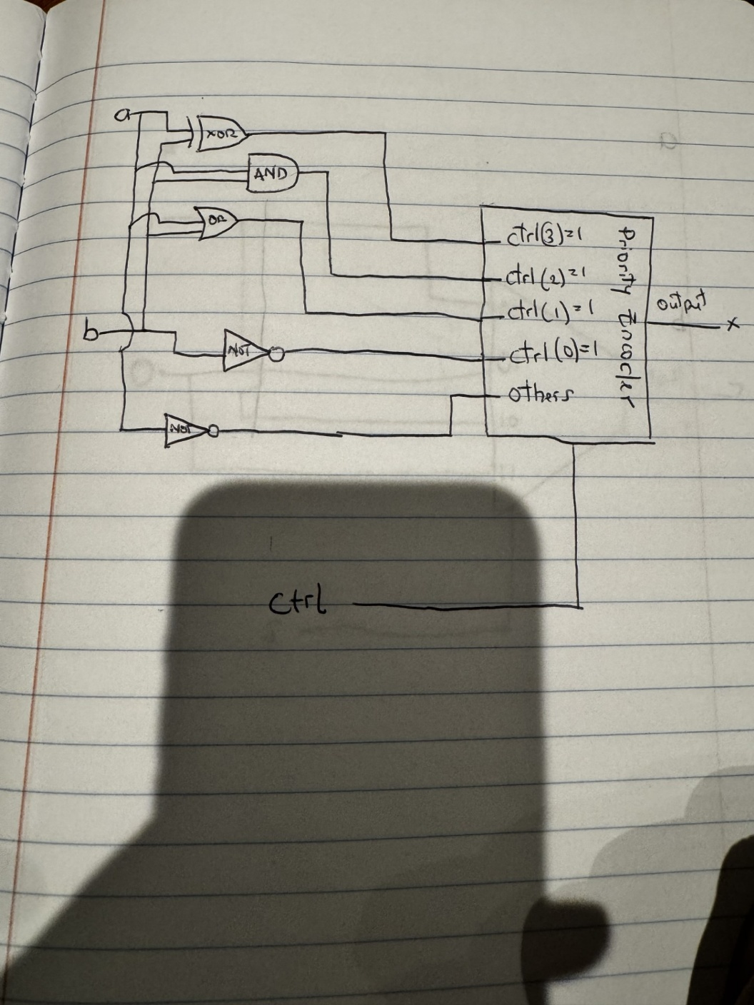
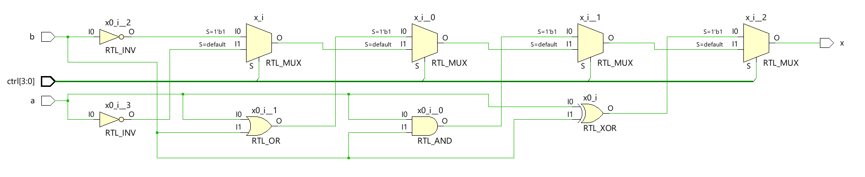
Components and Corresponding Code:
- NOT Gates (RTL_INV)
  - There are two NOT gates:
    - RTL_INV for not b: This gate inverts b, aligning with the code line not b when (ctrl(0) = '1').
    - RTL_INV for not a: This gate inverts a, corresponding to the else not a case in the code.
- Logic Gates:
  - XOR Gate (RTL_XOR):
    - Takes a and b as inputs and produces a xor b. This matches the line x <= a xor b when (ctrl(3) = '1').
  - AND Gate (RTL_AND):
    - Performs the a and b operation. This aligns with a and b when (ctrl(2) = '1') in the code.
  - OR Gate (RTL_OR):
    - Implements the a or b logic, corresponding to a or b when (ctrl(1) = '1').
- Multiplexers (RTL_MUX):
  - The schematic has several multiplexers:
    - Selection Logic:
      - The multiplexers are responsible for selecting the appropriate output based on the ctrl input vector.
      - Each multiplexer correlates with a conditional statement in the VHDL code.
      - Priority Selection: The S=default and S=1'b1 indicate priority encoding, ensuring the correct operation is chosen according to the priority defined in the code. If S=1’b1 is not fulfilled. The S=default is triggered, moving down to the next condition (multiplexer). If S=1’b1 is fulfilled, then it outputs to x immediately.
- Control Input (ctrl[3:0]):
  - The control signal (ctrl) is fed into the selection inputs of the multiplexers.
  - This enables the multiplexers to choose between the outputs of the logic gates (XOR, AND, OR, NOT gates) based on the priority defined in the VHDL code.
FPGA Testing & Explanation of Results.
The FPGA testing was conducted on the BASYS 3 board, using the implemented VHDL code and the configured constraint file. The objective was to validate the correct behavior of the "Logical Operation Unit" based on the "ctrl" input signals and observe the output "x" on the LED.
Test Results:
- ctrl = 0000: The "x" light is off. This indicates that the "not a" operation was executed, and since "a = 1," "not a" is "0," which correctly matches the expected outcome.
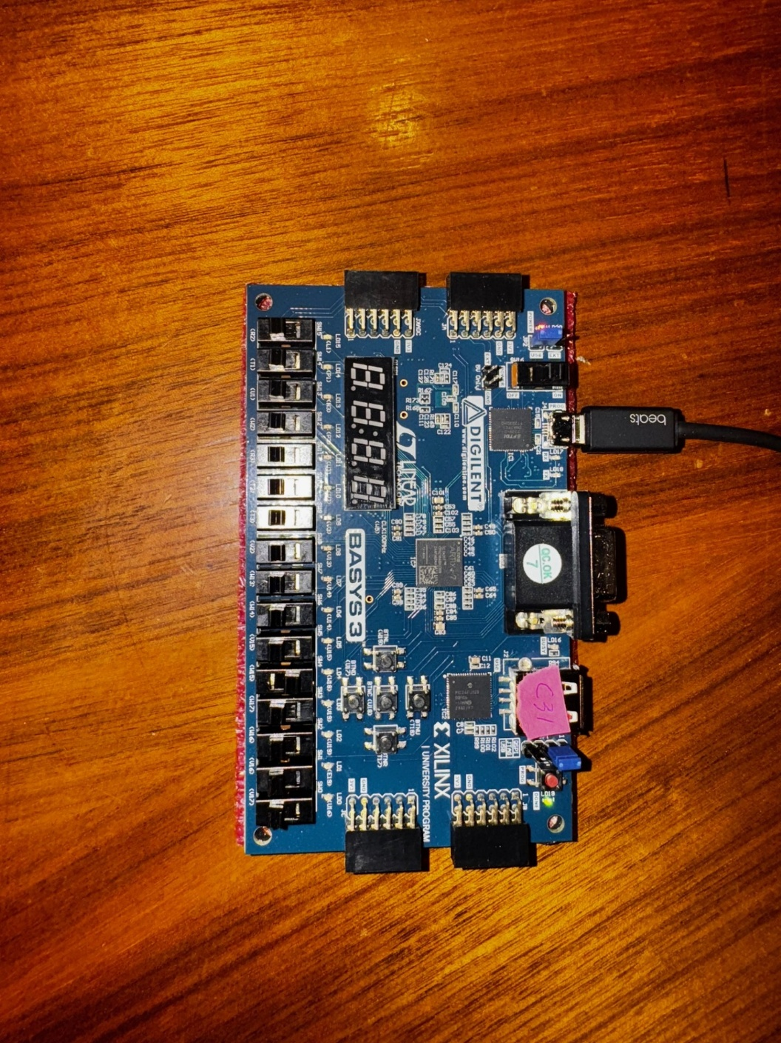
- ctrl = 0001: The "x" light is on. This indicates that the "not b" operation was executed. Since "b = 0," "not b" evaluates to "1," which is correctly shown by the lit LED.
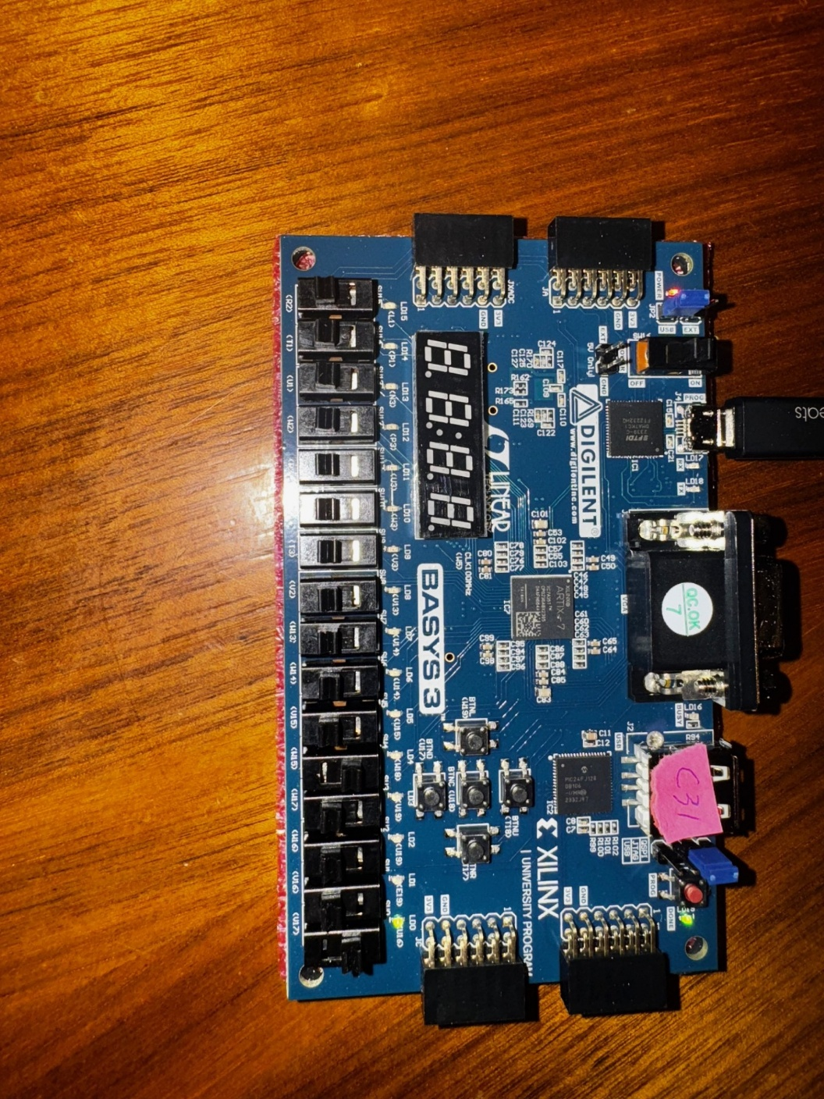
- ctrl = 0011: The "x" light is on. The priority encoder ensures that the highest active control bit determines the output. With "ctrl(3) = 0," "ctrl(2) = 0," and "ctrl(1) = 1," the "a or b" operation is triggered. Since "a = 1" and "b = 0," the output is "1," lighting up the LED.
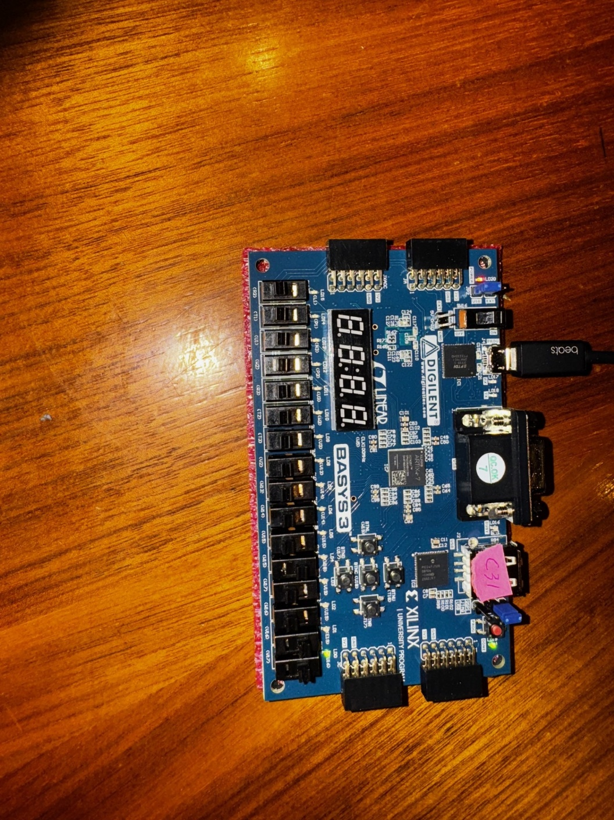
- ctrl = 0111: The "x" light is off. Here, the "a and b" operation is executed as the "ctrl(2)" bit is "1." Given "a = 1" and "b = 0," "a and b" evaluates to "0," which explains why the LED remains off.
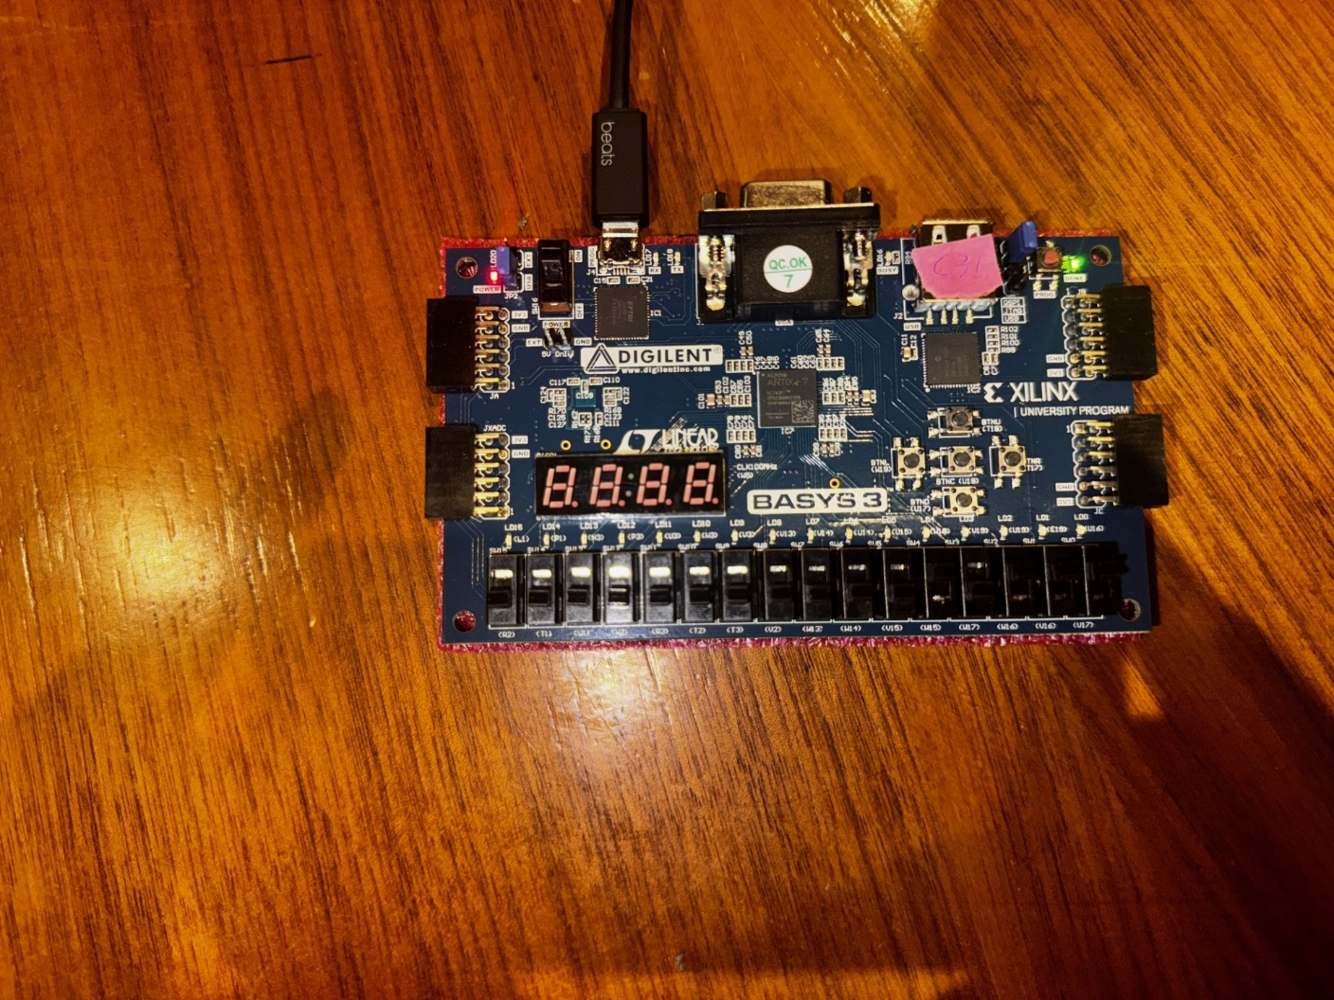
- ctrl = 1111: The "x" light is on. At this highest priority, the "a xor b" operation is active. With "a = 1" and "b = 0," "a xor b" evaluates to "1," correctly illuminating the LED.
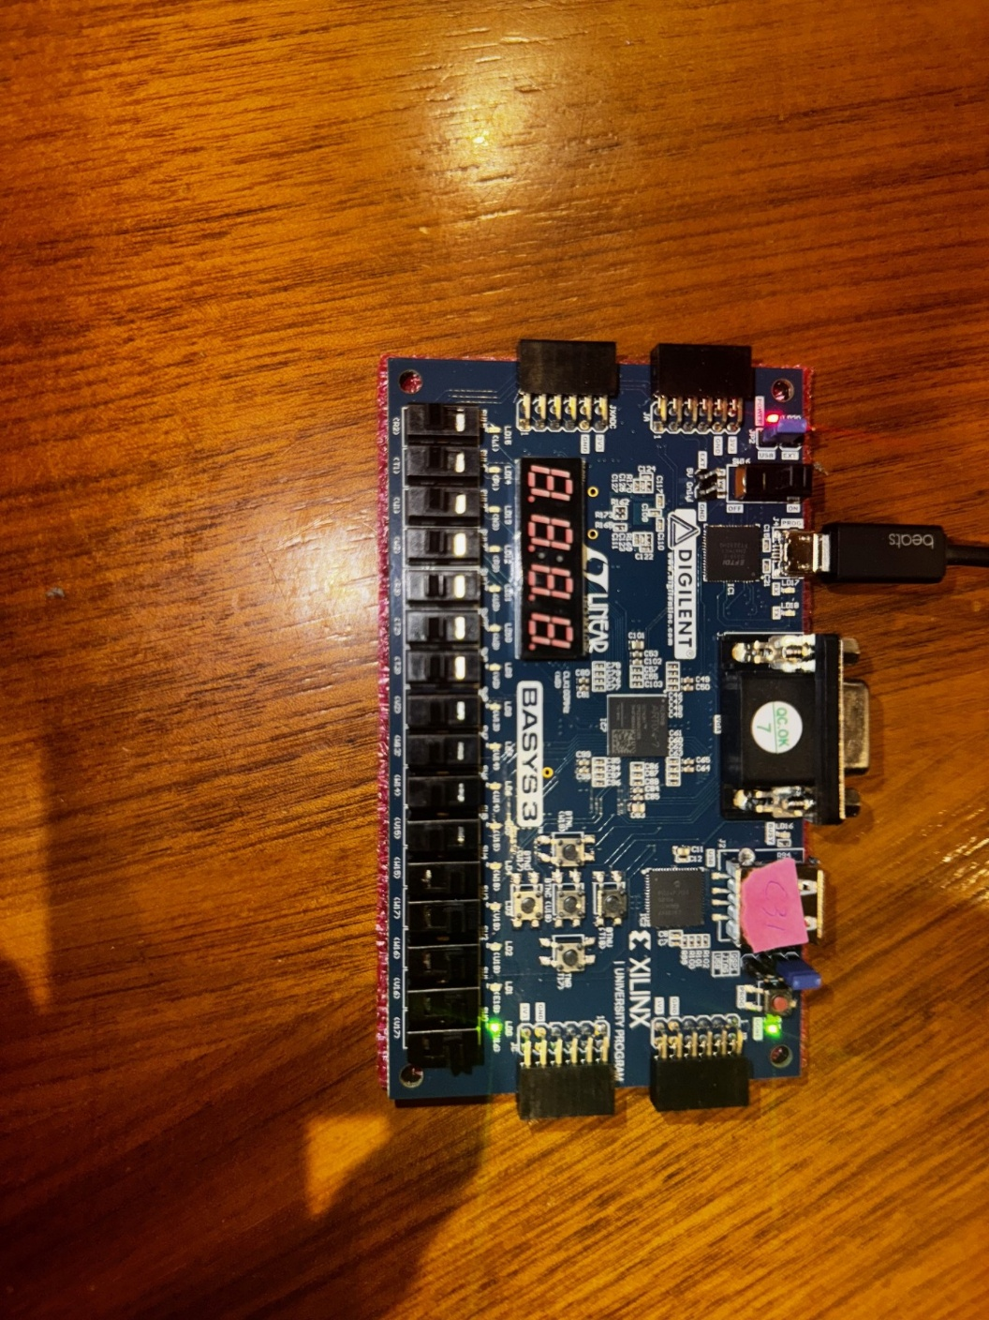
The observed results match the expected behavior of the logical operations and demonstrate that the priority structure of the "ctrl" signal is functioning as designed. The correct execution order of the logical operations, prioritized from "xor" to "not a," is validated through the physical test on the FPGA board.

Conclusion
This project successfully demonstrated the implementation of a logical operation unit using VHDL and the Basys 3 FPGA board. The design utilized conditional signal assignment to implement a priority-based logic selector, ensuring that only one logical operation was performed at a time based on the control signal. The FPGA testing confirmed that the output matched the expected results for each input scenario, validating the design's correctness and robustness. The use of the priority encoder logic in the VHDL code ensured that the design met all functional requirements and operated as intended on the physical hardware.

